**Why Mathematics Is So Important?**

Mathematics is the backbone of all sciences. There’s no career or profession where mathematics is not needed. It is involved in every microscopic and macroscopic process happening in our universe. Before describing the importance of Mathematics, it is crucial to know what Mathematics actually is.

# **What is Mathematics?**

Mathematics is much more than just crunching numbers. It is like a sixth sense. It is a very practical domain and it is not just about solving questions but also to ask the right questions. It combines imagination, creativity, critical thinking and logical reasoning. [1]

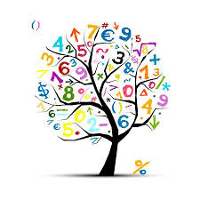

# **Importance of Mathematics in our daily lives**

Mathematics helps in coordinating our lives and lessens the chaos. It has a wide range of branches such as calculus, algebra, trigonometry, geometry, probability, number systems, etc. All are interlinked and facilitate each other. The primary knowledge of Mathematics is the foundation to help the brain in developing analytical skills. [2] Numbers and counting stimulates the part in brain responsible for rational thinking, by developing neural pathways for data processing. A researcher of Stanford University, **Dr. Tanya Evans** says that students who are good in mathematics have more gray matter in certain regions of the brain, than those who aren’t good in Mathematics. It not only enhances our problem-solving skills but also strengthens the brain as a whole and increases brain power. [3]

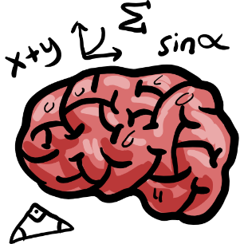

Humans have always pondered about the universe. Even in the early ages, they felt the need to look at things in a quantitative manner whether it was time, distance, weights, and other measurements, they used different rules to specify every digit. Mathematics wasn’t invented, it was discovered because it already existed and it continues to evolve as humanity is progressing. [4] It continues to explain the mechanism of how things actually work. Man’s curiosity to know about the stretches of space, the vastness of skies and the distance of stars gradually lead to the advancement of mathematics and the invention of trigonometry and Pythagoras theorem. Pyramids were built, long suspension bridges were made stable, and man landed on moon, all because of the advancements and research in Mathematics. There is a rule in mathematics called the **Golden ratio** (also called golden mean or golden section) [5] It is used in designing buildings by architects, making proportional drawings by artists, and scientists use applied mathematics to understand the recurring geometrical arrangement. For instance, there is a shape called **fractals**. It has infinite area, that is, they are never ending patterns. We see them everywhere, in hurricanes, tree, clouds, rivers and mountains, etc. [6]

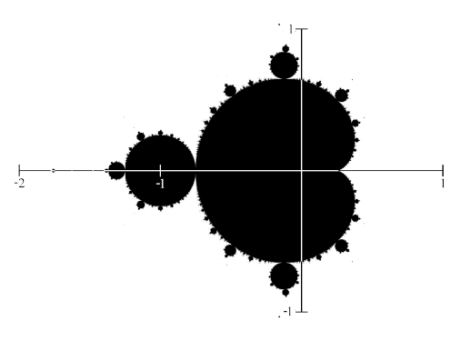

Not only is mathematics a very diverse discipline in itself, but it is also necessary to grasp the other science as well as arts fields. Researches related to medicine, physics, chemistry, economics, statistics, computer, engineering, all require the display of information in numerical form and all have questions that need to be answered with the help of basic arithmetic or any other easy or complex mathematical approach. In any subject we devise a mathematical formula to solve the problems of that subject and understand the theory in an objective way. [7] It also ensures increased accuracy of the devised formula when we solve it with some number-based data. It gives us a precise result and, in most cases, we can verify the result. Whether you want to be a CEO, a scientist, a real estate agent, a physicist, or a biologist, you’ll need to study MATH. Computer technology is also heavily based on math. The integrated circuits, coding, hardware, software, math is embedded in everything. [8]

Apart from the man-made processes, naturally occurring phenomenon such as entropy, change in time, motion of stars and planets and the various organized patterns we see in this world also require mathematical skills to be understood properly. For instance, clock is now used to tell the actual time whereas when clock wasn’t invented there were no means to know time correct up to a second and millisecond. We see order in this world because of its geometry and array. From the arrangement of the macroscopic bodies in the cosmos to the arrangement of microscopic bodies such as an electron in the orbit of an atom, and their shapes, all involve lots of mathematical knowledge. [9]

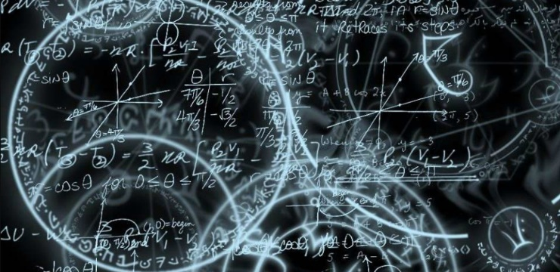

Insects, birds and animals also use mathematics, their brains are so designed that they can calculate distances and speeds in their heads which helps them to attack their prey and protect themselves from their predators. Similarly, the combs of honeybees have a hexagonal geometry, and spider webs also have a defined and symmetrical pattern. There is no need to use the terms of physics, biology and chemistry in mathematics textbooks but there’s always the need to use mathematical terms in these subjects because mathematics is a universal science and it is complete in itself. If there’s any universal language, it is math. People from various countries and from all the corners of the world need to understand the same rules and use the same digits. **Oakley** says that learning math is like playing with a new language. It doesn’t matter whether a person speaks English, French, Spanish or Arabic, solving a math problem, equations, theorems, formulas and proofs are done in the same way. All it requires is a good grasp of the concepts. [3]

# **Challenges in learning Math**

Some students are passive when it comes to doing math. “I love Math”, is what you should say if you want to sit alone in a class. The question is, why do many students face problems in understanding math? One of the reasons is a weak foundation, most students lack the understanding of basic rules, like if there are two minus signs then you are supposed to add the numbers. The other is computational weakness, because of the excessive dependence on calculators. This can be solved by practicing a lot. Some fault is of the tutors, who use wrong techniques and make math boring for students. The teachers should know how to answer the curious questions of their pupils, such as why is 0 factorial equal to one. Video demonstrations and other steps should be taken to teach REAL math to students, so they start seeing it as the universal language and give it the importance it deserves. [10]

# References

|  |  |
| --- | --- |
| [1] | "mathematics," 30 november 2021. [Online]. Available: https://en.wikipedia.org/wiki/Mathematics. |
| [2] | M. A. Quddusi, "what is the importance of mathematics in our daily lives," 7 november 2018. [Online]. Available: https://www.scientificworldinfo.com/2018/11/what-is-importance-of-mathematics-in.html?m=1. |
| [3] | S. Audsley, "6 reasons to study mathematics," 14 august 2019. [Online]. Available: https://www.phdstudies.com/article/6-reasons-to-study-mathematics/. |
| [4] | M. Lefkowitz, "why is math so important," 2018. [Online]. Available: https://blog.mindresearch.org/blog/why-is-math-so-important. |
| [5] | "Golden Ratio," [Online]. Available: https://en.m.wikipedia.org/wiki/Golden_ratio. |
| [6] | "what are fractals," [Online]. Available: https://fractalfoundation.org/resources/what-are-fractals/. |
| [7] | "the importance of math in everyday life," 3 august 2015. [Online]. Available: https://m.timesofindia.com/city/guwahati/the-importance-of-maths-in-everyday-life/articleshow/48323205.cms#:~:text=Mathematics%20makes%20our%20life%20orderly,and%20even%20effective%20communication%20skills.. |
| [8] | "What kind of math is used in computer engineering," 2021. [Online]. Available: https://www.effortlessmath.com/blog/what-kind-of-math-is-used-in-computer-programming/. |
| [9] | E. Hedrick, "The significance of mathematics," *The American Mathematical monthly,* vol. 24, no. 9, p. 6, 1917. |
| [10] | M. Ocadiz, "classroom," 26 september 2017. [Online]. Available: https://classroom.synonym.com/common-problems-students-mathematics-19834.html. |